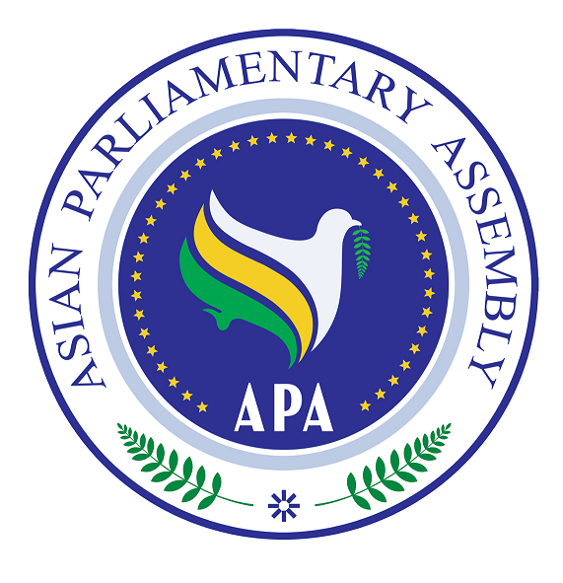

Statement by H.E. M.H. Nejad Hosseinian
The Secretary-General of the
Asian Parliamentary Assembly (APA)
before
The 122nd Meeting of the IPU Assembly

Bangkok, Thailand

27 March – 1 April, 2010

Mr. President,
Mr. Secretary-General,
Honorable Delegates,
Ladies and Gentlemen,

It is an honor for me to participate in the 122nd Meeting of the IPU Assembly. I am thankful to Honorable Mr. Theo-Ben Gurirab and Honorable Mr. Anders B. Johnson, President and Secretary General of the Inter-Parliamentary Union to provide me this opportunity and I am honored to present the views of the Asian Parliamentary Assembly on the important issues on the agenda of the present session of this august assembly.
The role of Parliaments to address the problems of our societies and to recommend the best available solutions is indisputable. Almost all APA Member Parliaments are also members of IPU and there are common subjects in the agendas of the two organizations. These are indications that we can cooperate on most of issues for the benefit of the peoples in Asia and across the world. Therefore, IPU and APA each can combine the potentials of their member parliaments to advance their programs and objectives.
Asian Parliamentary Assembly, in some way, is representing Asia which as a vast continent with rich resources and has great potentials to find solutions to its problems and also to contribute to the advancement of the world economy. However, Asia still faces many challenges such as poverty, illiteracy, unemployment, malnutrition, severe health problems, environmental degradation and financial crisis. Considering the similarities between the objectives and the current agendas of APA and IPU, we can work together to promote cooperation and friendship in Asia and in the entire world.

Asian Parliamentary Assembly attaches great importance to multilateralism and international cooperation. Bearing in mind the diversities of Asian cultural, political and economic experiences, we are convinced that only through cooperation and sharing experiences and best practices, we can achieve prosperity and economic development. It is in this context that APA considers its participation in IPU meetings indispensable where parliamentarians from different continents can interact and exchange view and share experiences.

On issues related to the Third Standing Committee (Democracy and Human Rights), the APA has promoted human rights and individual freedom, political liberty and the rule of law. It has also recognized the rights and freedom of nations. APA actively follows the developments in Palestine including the atrocities committed by the Israeli regime in that country. In our 4th Plenary Session held on last December, Resolution on Violations of International Humanitarian Law in the Palestine and the War Crimes Committed by the Zionist Regime in Gaza was adopted. The Resolution Encourages all members of the international community to put pressure on the Zionist regime to immediately cease the Gaza siege and let the Palestinian people resume their normal life and begin reconstruction of the damaged areas. It also Calls upon the Zionist regime, to withdraw from all the occupied territories and to release all the Palestinian prisoners including the Members of the Palestinian Parliament; dismantle all the settlements as well as the entire separating wall, and all the checkpoints in the occupied Palestinian lands; and put an end to its policies of confiscating Palestinian lands.
In conclusion, I would like to take this opportunity once again, to express my thanks to the IPU President and the Secretary-General for inviting me to participate in this general debate.
Thank you.

